

**UNIVERSITI MALAYSIA TERENGGANU**

**CSM3023 – WEB PROGRAMMING 2**

**BACHELOR OF COMPUTER SCIENCE (MOBILE COMPUTING) WITH HONORS**

**LAB 7 – JSP: Perform Create, Update, Retrieve and Delete (CRUD)**

**SEMESTER II 2023/2024**

**Prepared for:**

DR MOHAMAD NOR BIN HASSAN

**Prepared by:**

AHMAD SHAZRUL IZZUAN BIN AHMAD FITIRI @ FITRI

(S67250)

# Step 1 - Create three Java class that representing User (act as a JavaBeans to represent business object), DBConnection (to open and close database connection) and UserDao (act as a Data Access Object (DAO)) to perform CRUD process

## User.java

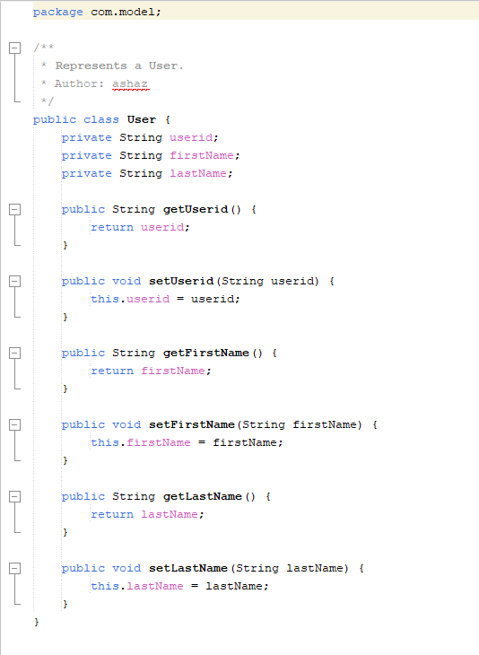

## DBConnection.java

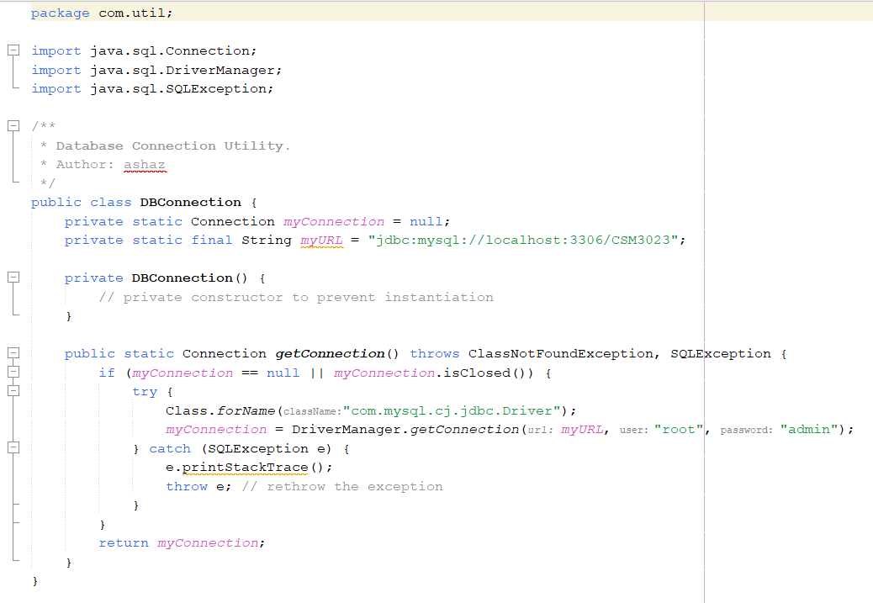

## UserDao.java

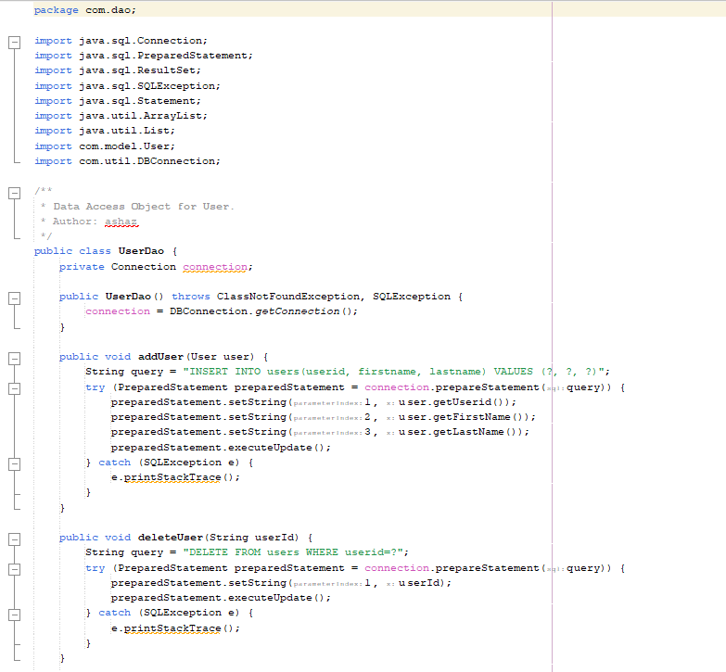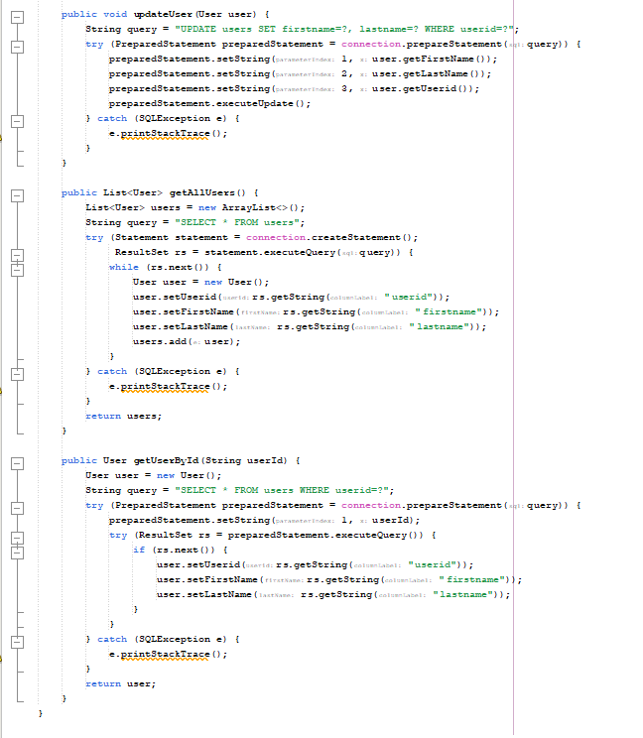

# Step 3 - Create UserController servlet in order to control and redirect the request to the respective CRUD process and page

## UserController.java

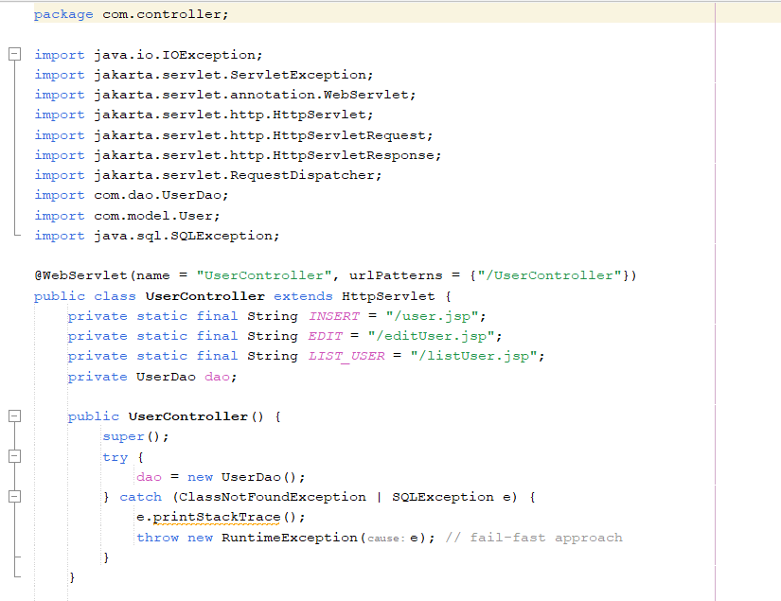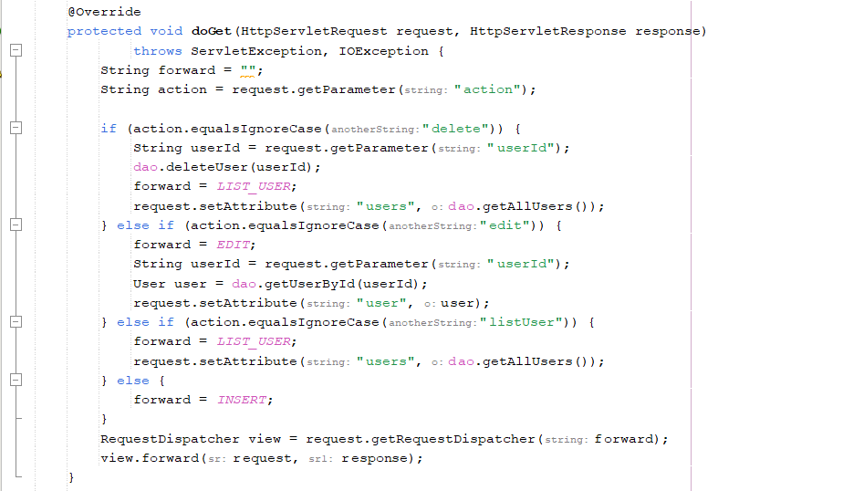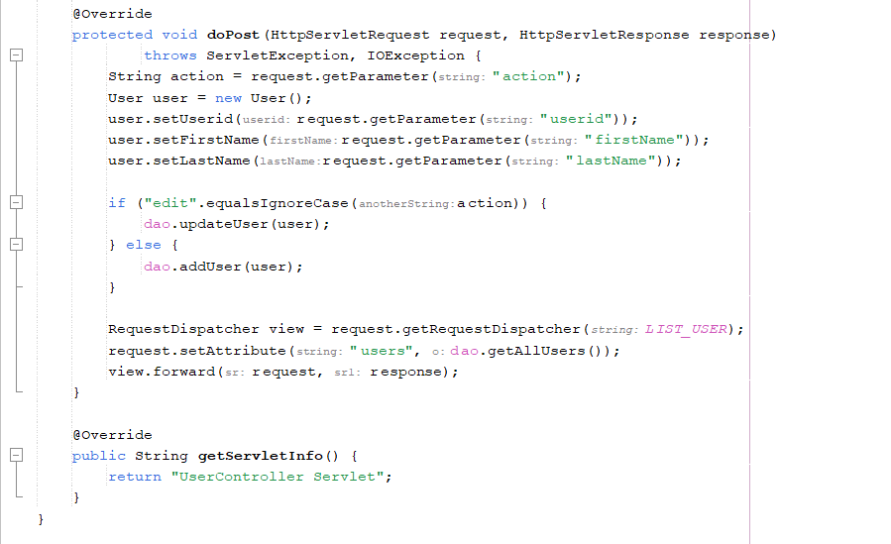

**Step 4 - Create an index.jsp page that act as a main page**

## index.jsp

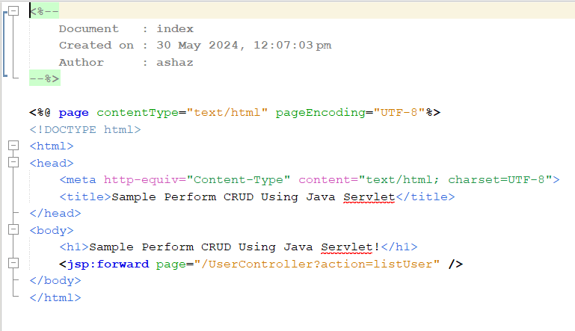

**Step 5 - Create listUser.jsp page to perform retrieving of a list of users.**

## listUser.jsp

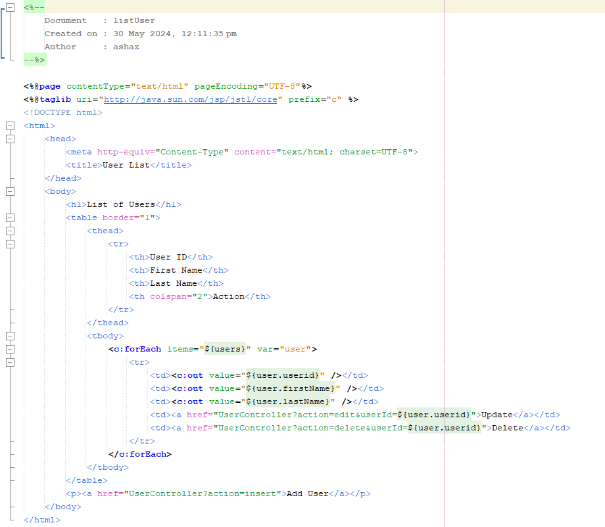

**Step 6 - Create user.jsp page as a page for creating new record for user.**

## user.java

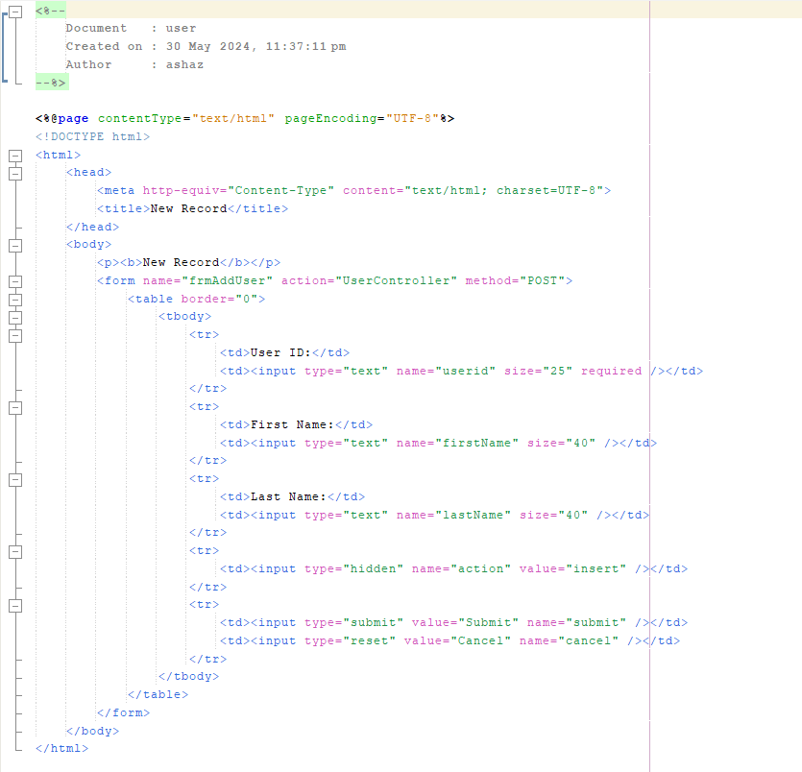

**Step 7 - Create editUser.jsp page as a page for updating existing record for**

**specific user.**

## editUser.java

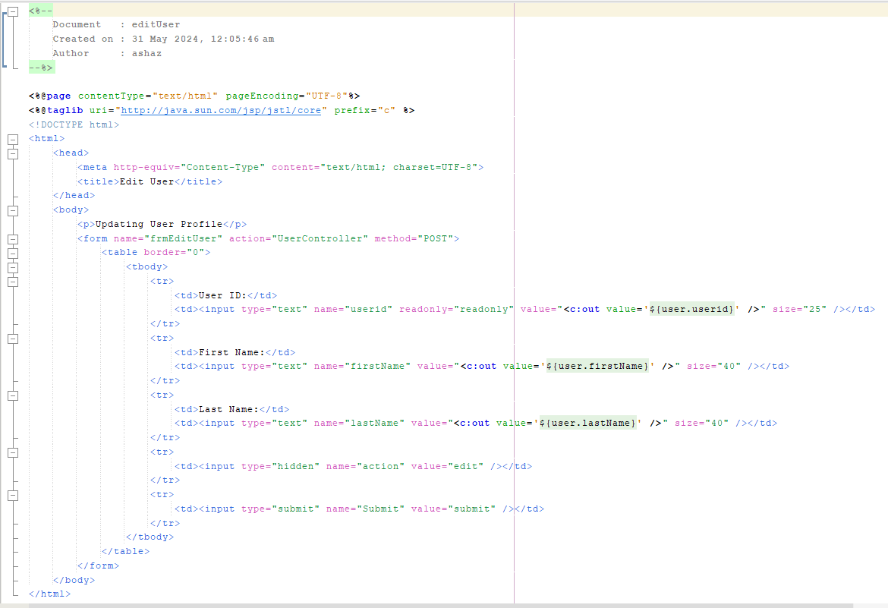

Output :

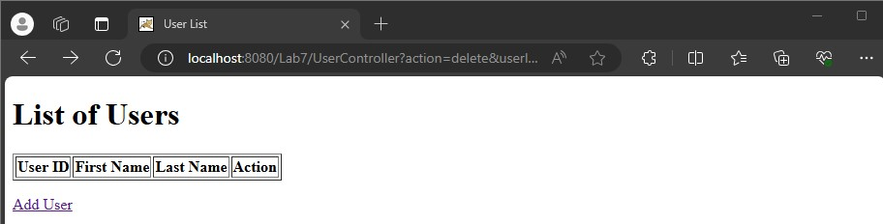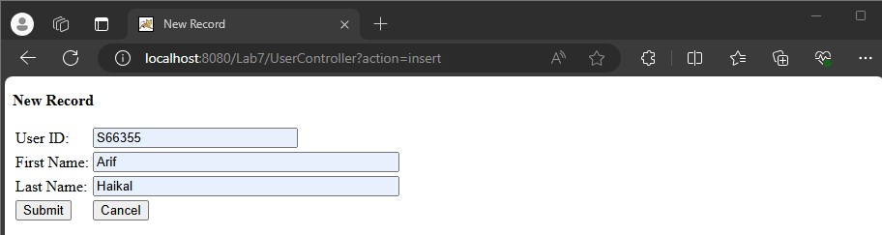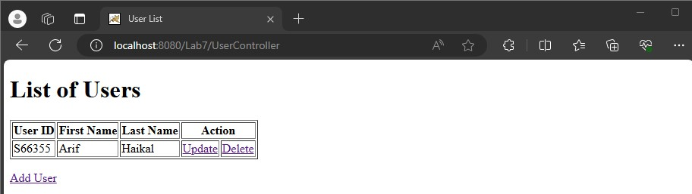

Update :

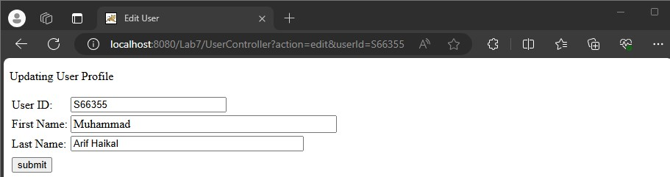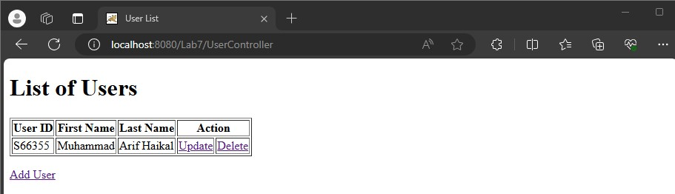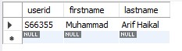

Delete :



**Reflection:**

1. Why we use servlet for Java Web Application?

Servlets allow the server to manage client requests and provide dynamic web content, we utilise them for Java web applications. Servlets are necessary for developing responsive and interactive web applications because they handle incoming requests, communicate with databases or other resources, and return results to the client.

# Exercise

**Q1) Implement profile registration using servlet**

## profileForm.html

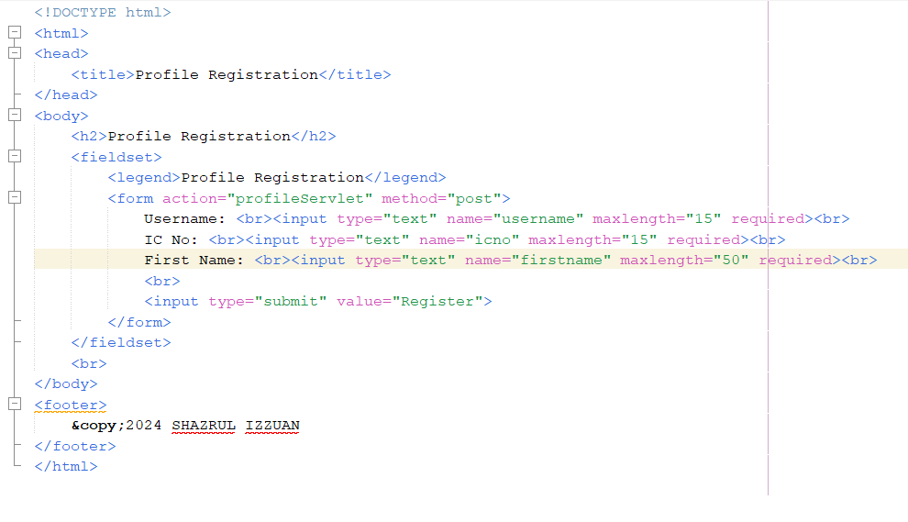

## profileServlet.java

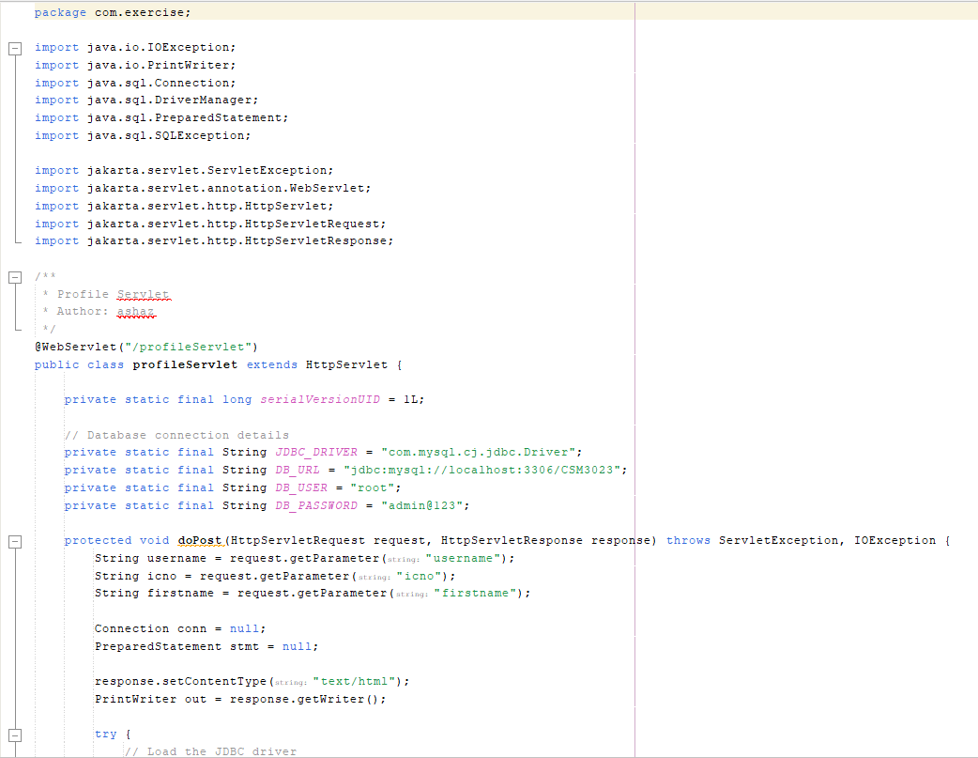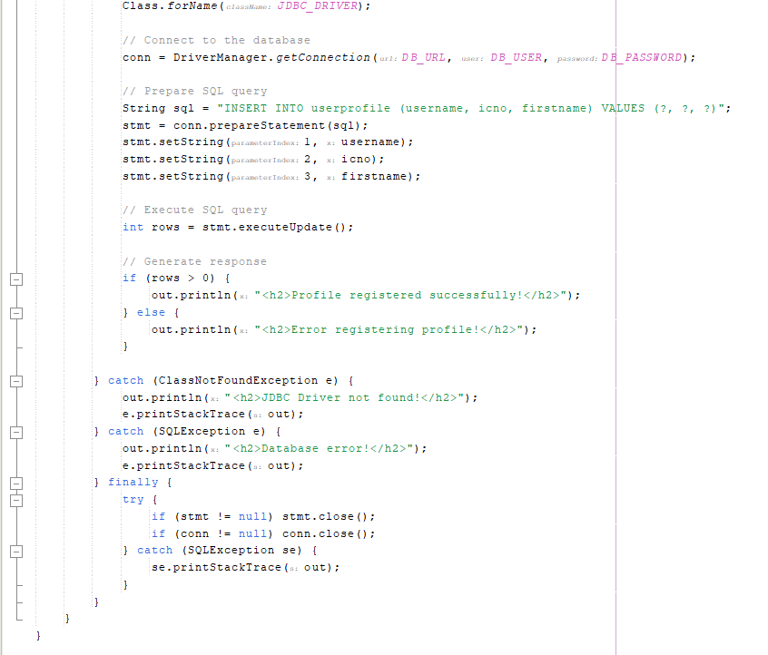

Output :

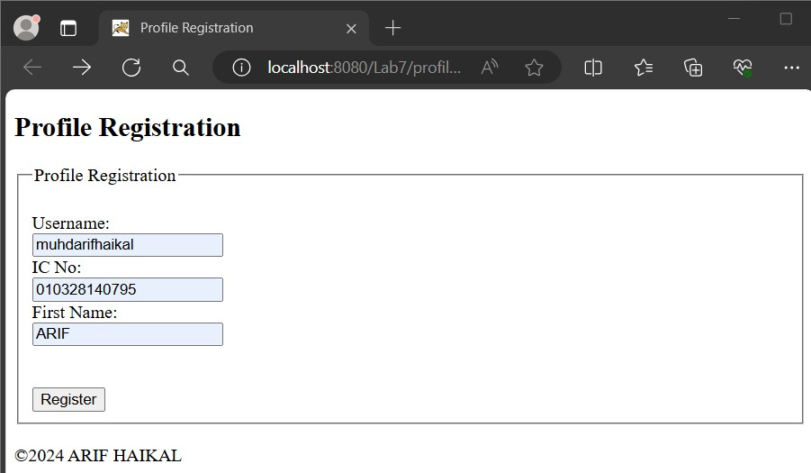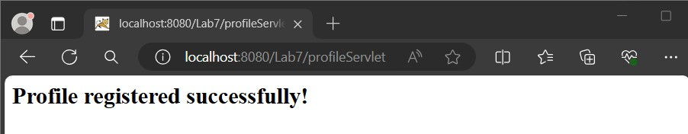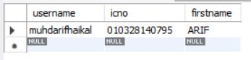

When you duplicate :

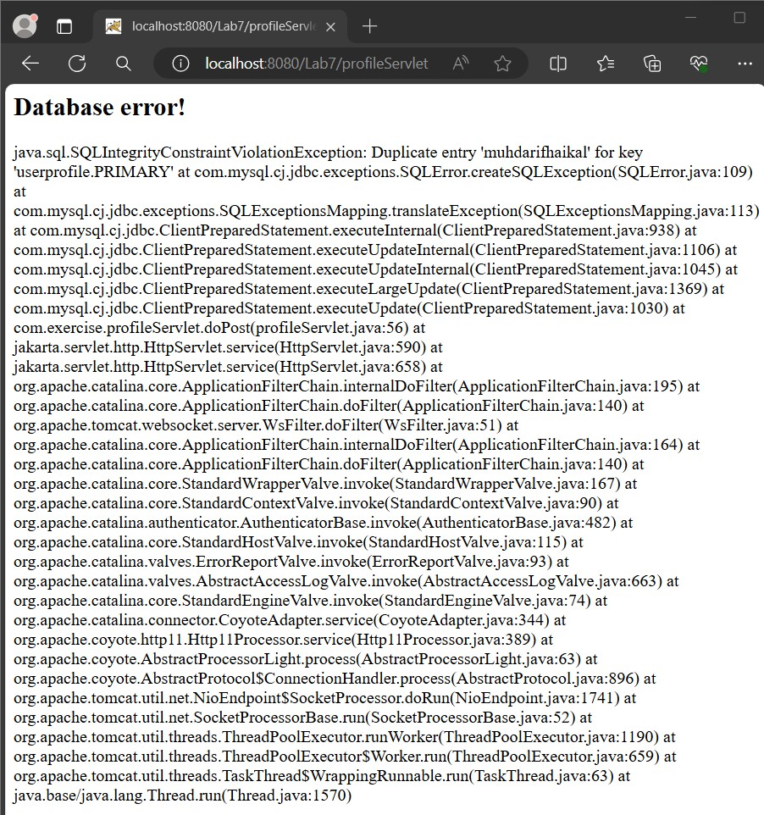

**Q2) Applying session in student registration.**

## studentRegister.jsp

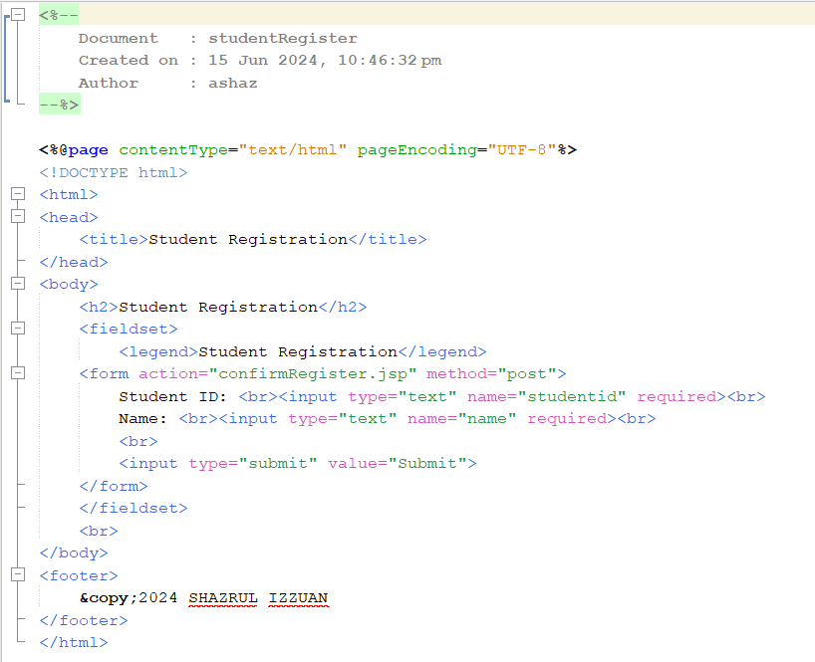

## confirmRegister.jsp

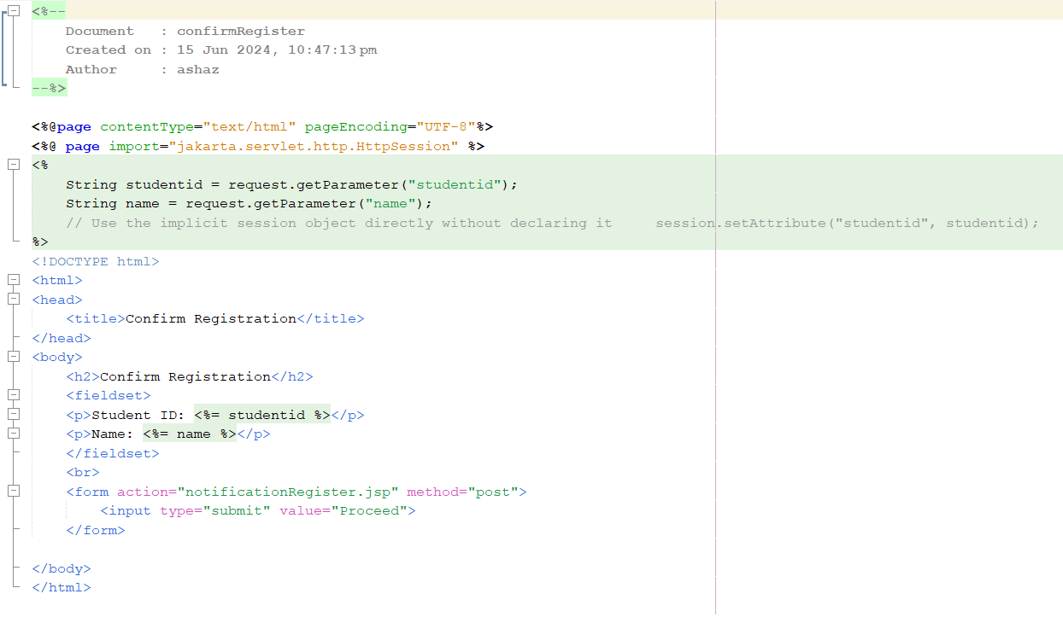

## notificationRegister.jsp

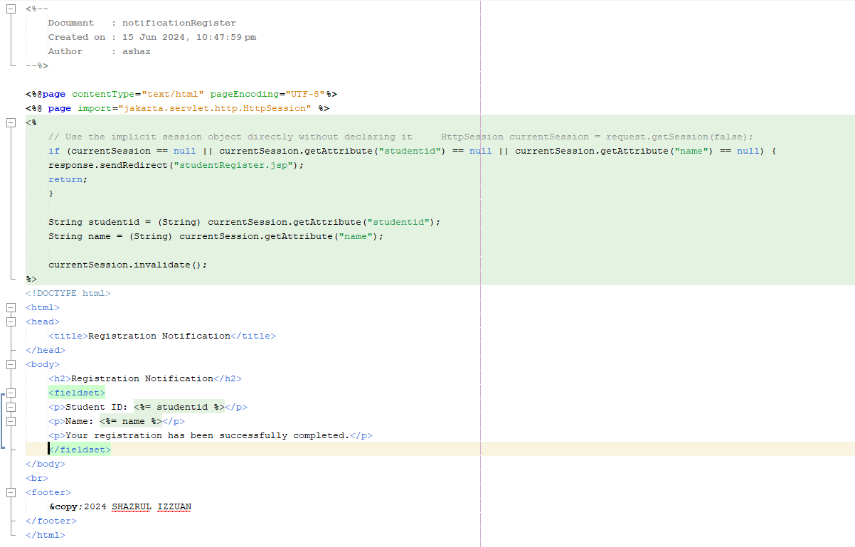

Output :

